**Chapter-2**

1. 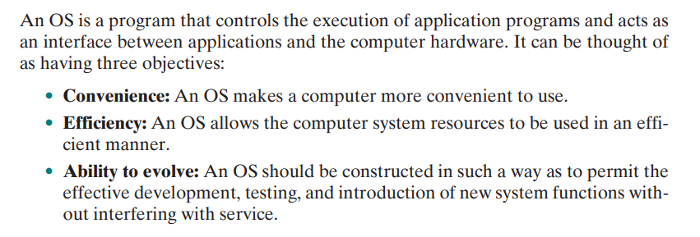Discuss the objectives of the operating system.
2. Briefly discuss the evolution of the operating system. (How operating system evolved over the years?)

The evolution of operating systems can be traced through several key stages, each marked by significant advancements in technology and computing paradigms. Here is a brief overview of the evolution of operating systems over the years:

**1) First Generation (1940s-1950s)**:

The first electronic computers used no operating system. Programs were manually loaded using switches and dials.

Batch processing systems were developed, allowing multiple jobs to be submitted and executed sequentially without user intervention.

**2) Second Generation (1950s-1960s)**:

The introduction of batch processing systems led to the development of early operating systems like GM-NAA I/O and IBM's OS/360.

Time-sharing systems emerged, enabling multiple users to interact with a computer simultaneously.

1. **Third Generation (1960s-1970s)**:

The development of multiprogramming systems allowed multiple programs to run concurrently.

Operating systems like Unix and Multics introduced concepts such as hierarchical file systems and shell interfaces.

1. **Fourth Generation (1980s-1990s)**:

Graphical user interfaces (GUIs) became popular with the introduction of operating systems like Apple's Macintosh and Microsoft Windows.

Client-server computing models and networking capabilities were integrated into operating systems.

1. **Fifth Generation (2000s-Present)**:

The rise of mobile computing led to the development of operating systems for smartphones and tablets, such as iOS and Android.

Virtualization technologies and cloud computing have influenced modern operating systems, enabling greater flexibility and scalability.

1. **Current Trends**:

Modern operating systems focus on security, virtualization, and cloud integration.

The shift towards containerization and microservices has influenced the design of operating systems to support these new paradigms.

Discuss five major theoretical advances in the development of operating systems.

1. **Monolithic vs. Microkernel Architecture**:
   1. Traditionally, operating systems have utilized monolithic kernel architectures, where a single kernel process handles most OS functionalities. These functionalities include scheduling, file systems, networking, device drivers, and memory management.
   2. However, the microkernel architecture presents an alternative approach. In this design, only essential functions such as address spaces, interprocess communication (IPC), and basic scheduling are implemented within the kernel. Other OS services are provided by separate user-mode processes, often called servers.
   3. Microkernel architecture offers several benefits, including flexibility, ease of implementation, and suitability for distributed environments. It enables the decoupling of kernel and server development, allowing servers to be customized to specific application or environment requirements.
2. **Multithreading**:
   1. Multithreading involves dividing a single process into multiple threads, each capable of executing concurrently. Threads share the same memory space within a process but have their own program counters and stack pointers.
   2. This approach provides greater control over the modularity and timing of application-related events. It is particularly useful for applications that perform independent tasks that do not need to be serialized.
   3. Multithreading can lead to more efficient resource utilization and improved responsiveness in applications, as threads can execute concurrently on multicore processors.
3. **Symmetric Multiprocessing (SMP)**:
   1. SMP refers to a computer hardware architecture and OS behavior that exploit multiple processors within a system.
   2. In an SMP system, the OS schedules processes or threads across all available processors, enabling parallel execution of tasks.
   3. SMP offers advantages such as improved performance, availability, incremental growth, and scalability. It allows multiple processes to run simultaneously, each on a different processor.
   4. The existence of multiple processors is transparent to the user, as the OS handles scheduling and synchronization among processors to provide a unified system appearance.
4. **Distributed Operating Systems**:
   1. Distributed operating systems provide the illusion of a single main memory space and secondary memory space across a cluster of separate computers.
   2. These systems enable distributed computing by coordinating resources and providing unified access facilities such as distributed file systems.
   3. Despite their potential benefits, the development of distributed operating systems lags behind that of uniprocessor and SMP operating systems.
5. **Object-Oriented Design**:
   1. Object-oriented design principles are increasingly being applied in OS development to enhance modularity and customization.
   2. An object-based structure enables programmers to add modular extensions to a small kernel without disrupting system integrity.
   3. Object-oriented design also facilitates the development of distributed tools and full-blown distributed operating systems by providing a disciplined approach to system design and implementation.
6. Briefly discuss the categories of information protection and security related to operating systems.

Information protection and security are critical aspects of operating systems to ensure the confidentiality, integrity, and availability of data. Here are the key categories of information protection and security related to operating systems:

1. **Access Control**:
   * Access control mechanisms regulate who can access what resources in the system. This includes user authentication, authorization, and permission management.
   * Operating systems use access control lists (ACLs), capabilities, and role-based access control (RBAC) to enforce access policies and prevent unauthorized access to sensitive data.
2. **Data Encryption**:
   * Data encryption is used to protect data at rest and in transit. Operating systems provide encryption mechanisms to secure files, communication channels, and storage devices.
   * Techniques like full-disk encryption, file-level encryption, and secure communication protocols help prevent unauthorized access to data.
3. **Auditing and Logging**:
   * Auditing and logging mechanisms track system activities and events to detect security breaches, unauthorized access attempts, and suspicious behavior.
   * Operating systems maintain audit logs that record user actions, system events, and security-related activities for forensic analysis and compliance purposes.
4. **Firewalls and Network Security**:
   * Operating systems include firewall software to monitor and control network traffic, filtering incoming and outgoing data packets based on predefined rules.
   * Network security features like intrusion detection systems (IDS), virtual private networks (VPNs), and secure sockets layer (SSL) protocols enhance the security of network communications.
5. **Malware Protection**:
   * Operating systems incorporate antivirus software, anti-malware tools, and security patches to protect against viruses, worms, ransomware, and other malicious software.
   * Regular updates and security patches help mitigate vulnerabilities and prevent malware infections that can compromise system security.
6. **Secure Boot and Trusted Computing**:
   * Secure boot mechanisms ensure that only trusted software components are loaded during the system startup process, preventing unauthorized code execution.
   * Trusted computing technologies, such as Trusted Platform Module (TPM), provide hardware-based security features for secure storage, cryptographic operations, and system integrity verification.
7. 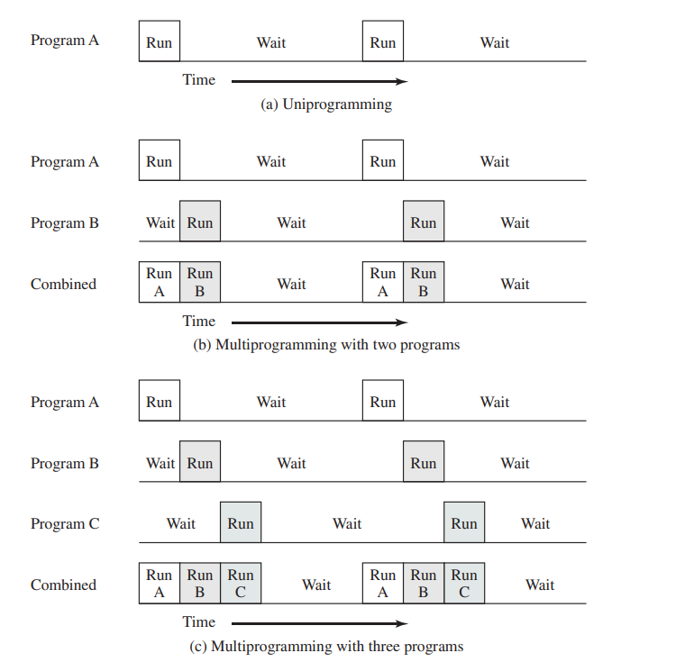Discuss key elements of the operating system for multiprogramming with the figure.
8. **Memory Management**:
   * Multiprogramming requires efficient memory management to allocate and deallocate memory for multiple processes running concurrently.
   * The operating system must manage memory partitions, handle memory protection, and support virtual memory to optimize memory utilization.
9. **Process Scheduling**:
   * Process scheduling is crucial in multiprogramming to determine the order in which processes are executed on the CPU.
   * The operating system uses scheduling algorithms to allocate CPU time to processes, ensuring fair execution and optimal system performance.
10. **I/O Device Management**:
    * Multiprogramming involves managing I/O devices efficiently to handle input and output operations for multiple processes.
    * The operating system coordinates I/O requests, handles device interrupts, and ensures proper data transfer between processes and I/O devices.
11. **File System**:
    * A robust file system is essential for multiprogramming to store and organize data for multiple processes.
    * The operating system provides file management services, including file creation, deletion, access control, and data retrieval, to support concurrent access to files.
12. **Concurrency Control**:
    * Multiprogramming introduces concurrency among processes, requiring mechanisms to control access to shared resources and prevent data inconsistencies.
    * The operating system implements synchronization techniques like locks, semaphores, and monitors to coordinate access to critical sections of code and shared data.
13. **Error Handling and Recovery**:
    * Operating systems for multiprogramming must handle errors and exceptions to ensure system stability and data integrity.
    * Error detection mechanisms, exception handling routines, and recovery strategies are implemented to address faults and failures in the system.
14. **System Calls and APIs**:
    * Multiprogramming operating systems provide system calls and application programming interfaces (APIs) for processes to interact with the underlying system resources.
    * System calls enable processes to request services from the operating system, such as I/O operations, process creation, and memory allocation.
15. Briefly discuss the operating system design hierarchy in level 13 to level 1.

The operating system design hierarchy typically consists of multiple levels, each focusing on different aspects of system functionality and abstraction. Here is a brief overview of the operating system design hierarchy from level 13 to level 1:

Level 13: **User Programs**

* At the highest level, user programs interact with the operating system through system calls and APIs to access system resources and services.
* User programs include applications, utilities, and software that run on top of the operating system.

Level 12: **System Calls**

* System calls provide an interface between user programs and the operating system kernel.
* User programs make requests to the operating system by invoking system calls, which trigger the execution of specific kernel functions.

Level 11: **Kernel Interface**

* The kernel interface defines the boundary between user space and kernel space.
* It includes the system call table, which maps system call numbers to corresponding kernel functions, and handles the transition from user mode to kernel mode.

Level 10: **Kernel**

* The kernel is the core component of the operating system that manages system resources, provides essential services, and enforces system policies.
* It includes modules for process management, memory management, file system, device drivers, and other critical functions.

Level 9: **Device Drivers**

* Device drivers are software components that facilitate communication between the operating system and hardware devices.
* They abstract hardware-specific details, handle device I/O operations, and enable the operating system to interact with peripherals.

Level 8: **Hardware Abstraction Layer (HAL)**

* The Hardware Abstraction Layer provides a uniform interface to hardware components, abstracting hardware variations and complexities.
* It isolates the operating system from hardware details, allowing portability across different hardware platforms.

Level 7: **Microkernel**

* The microkernel architecture separates the core operating system services from additional functionalities, running them as user-space processes.
* It minimizes the kernel size and complexity, improving system reliability, security, and flexibility.

Level 6: **Operating System Services**

* Operating system services include process management, memory management, file system operations, I/O management, and networking services.
* These services are essential for system operation and provide a foundation for higher-level functionalities.

Level 5: **System Libraries**

* System libraries contain reusable code modules that provide common functions and utilities to user programs.
* They encapsulate system-specific operations and simplify application development by offering pre-built functions.

Level 4: **System API**

* The System API defines a set of functions and data structures that user programs can use to interact with the operating system.
* It serves as an abstraction layer that shields user programs from low-level system details.

Level 3: **System Call Interface**

* The System Call Interface specifies the conventions and mechanisms for invoking system calls from user programs.
* It defines how parameters are passed, how system calls are executed, and how results are returned to user programs.

Level 2: **System Call Handler**

* The System Call Handler is responsible for receiving system calls from user programs, validating parameters, and dispatching requests to the appropriate kernel functions.
* It ensures proper execution of system calls and enforces security and access control policies.

Level 1: **Hardware**

* At the lowest level, hardware components such as the CPU, memory, storage devices, and peripherals form the physical foundation of the system.
* The operating system interacts with hardware to manage resources, execute instructions, and provide services to user programs.

**Chapter-3**

1. What is the process? Explain the process control block with the necessary figure in brief.

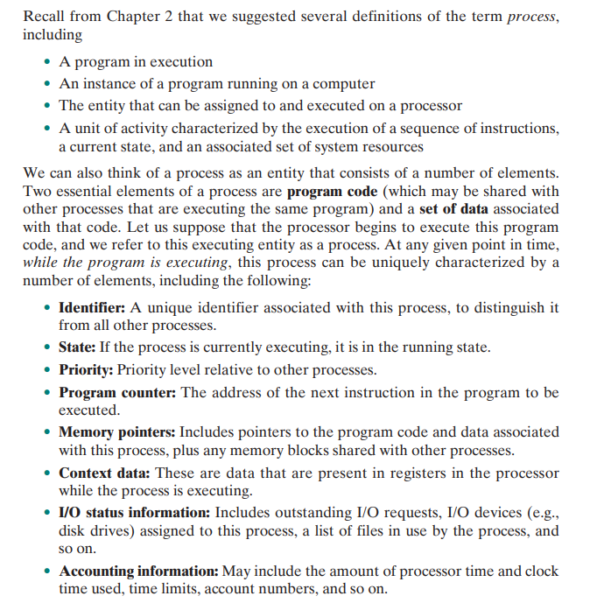

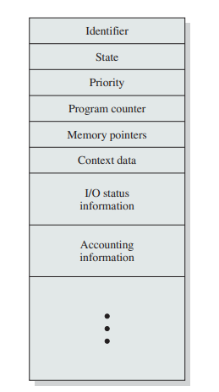

1. Explain the two-state process model with the necessary figure.

Book Pg. – 136 & 137

1. 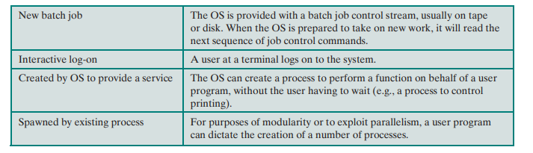Briefly discuss the reasons for process creation.
2. Briefly discuss the reasons for process termination.

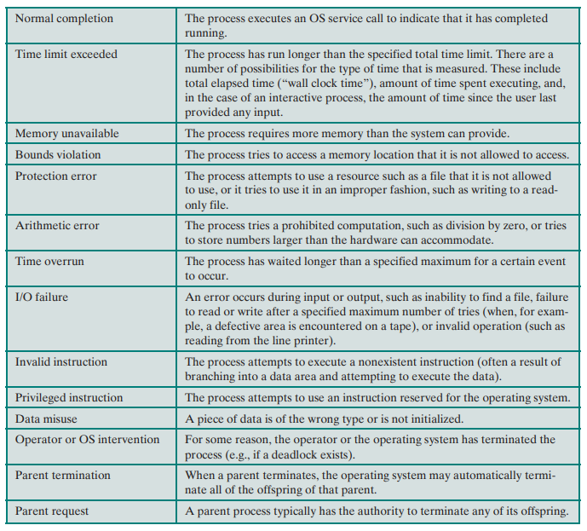

1. Explain the five-state process model in detail.

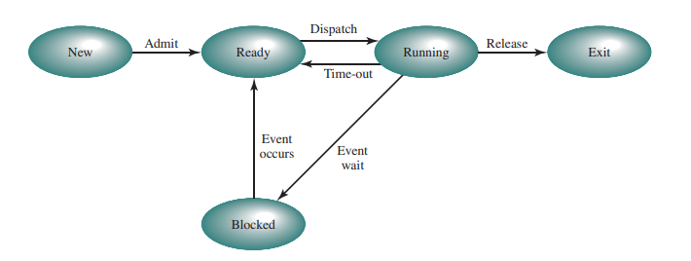

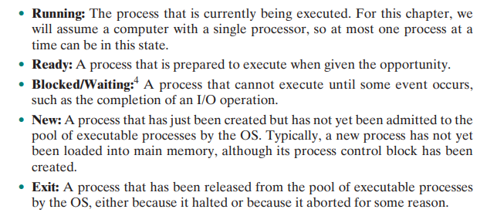

1. What are ready queues and blocked queues?
2. **Ready Queues**:
   * **Definition**: Ready queues are data structures that hold processes that are ready to run but are waiting for the CPU to be allocated to them. Processes in the ready state are placed in the ready queue by the CPU scheduler.
   * **Purpose**: The ready queue allows the operating system to efficiently manage the scheduling of processes for execution on the CPU. Processes in the ready queue are candidates for CPU execution and are typically prioritized based on scheduling algorithms.
   * **Multiple Queues**: Some operating systems use multiple ready queues to categorize processes based on their priority levels or scheduling criteria. This allows for more sophisticated scheduling policies, such as priority scheduling or round-robin scheduling.
   * **Dispatching**: When the CPU scheduler selects a process from the ready queue to run on the CPU, the process is moved from the ready queue to the running state.
3. **Blocked Queues**:
   * **Definition**: Blocked queues are data structures that hold processes that are blocked or waiting for a specific event to occur before they can proceed. Processes in the blocked state are placed in the blocked queue by the operating system.
   * **Purpose**: The blocked queue allows the operating system to efficiently manage processes that are waiting for external events, such as I/O operations or resource availability. Placing blocked processes in a separate queue helps in tracking their status and managing their transition back to the ready state.
   * **Event Completion**: When the event a blocked process is waiting for occurs (e.g., completion of an I/O operation), the process is moved from the blocked queue back to the ready queue, where it can be considered for CPU execution.
   * 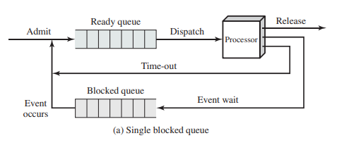**Resource Management**: Blocked queues help in resource management by temporarily suspending processes that cannot make progress, thereby allowing other processes to utilize system resources effectively.
4. What is suspended process?

A suspended process is a process that has been temporarily removed from active execution by the operating system. There are two main types of suspended processes:

1. **Blocked Suspended Process**:
   * A blocked suspended process is a process that is in a blocked state and has been temporarily suspended by the operating system. This typically occurs when a process is waiting for a specific event to occur, such as I/O completion or resource availability. The process is moved from the ready queue to the blocked queue and is considered suspended until the event it is waiting for happens. Once the event occurs, the process can be unblocked and moved back to the ready queue for execution.
2. **Ready Suspended Process**:
   * A ready suspended process is a process that is in a ready state but has been suspended by the operating system. This type of suspension may occur due to various reasons, such as priority changes, resource constraints, or user intervention. The process is still ready to run but is temporarily held back from execution. Once the suspension condition is lifted, the process can be resumed and scheduled for execution on the CPU.
3. Briefly explain the need for swapping.

Swapping is a technique used by operating systems to manage memory efficiently when the system's physical memory (RAM) is insufficient to hold all the processes that are currently active. Here is a brief explanation of the need for swapping:

1. **Memory Overcommitment**:
   * In a multitasking environment, where multiple processes are running simultaneously, the total memory required by all processes may exceed the available physical memory. This situation leads to memory overcommitment, where the system needs to find a way to accommodate all processes efficiently.
2. **Optimal Resource Utilization**:
   * Swapping allows the operating system to optimize resource utilization by moving inactive or less frequently used processes from memory to disk. By swapping out these processes, the system can free up physical memory for more critical or actively running processes, thereby maximizing the utilization of available resources.
3. **Process Scheduling**:
   * Swapping plays a crucial role in process scheduling and management. When a process is not actively using the CPU or is waiting for I/O operations, the operating system can swap out the process to disk to make room for other processes that require immediate execution. This swapping enables efficient process scheduling and ensures that the CPU is utilized effectively.
4. **Preventing System Instability**:
   * Without swapping, if the system runs out of physical memory, it may lead to system instability, performance degradation, or even system crashes. Swapping helps prevent such scenarios by providing a mechanism to move processes to disk and maintain system stability under memory constraints.
5. **Virtual Memory Support**:
   * Swapping is essential for supporting virtual memory systems, where the operating system uses a combination of physical memory and disk space to create the illusion of a larger memory space than physically available. Swapping allows the system to transparently move data between RAM and disk, providing a seamless memory management experience to applications.
6. **Improved Responsiveness**:
   * By swapping out less active processes to disk, the operating system can ensure that more critical processes have faster access to physical memory, leading to improved system responsiveness and reduced latency in executing important tasks.
7. Explain the process state transition diagram with one suspended state.

A process state transition diagram illustrates the various states that a process can go through during its execution in an operating system. Including a suspended state in the diagram allows for a more comprehensive representation of process management. Here is an explanation of a typical process state transition diagram with one suspended state:

1. **Process States**:
   * **New**: The process is being created or initialized.
   * **Ready**: The process is ready to run and waiting for CPU allocation.
   * **Running**: The process is currently being executed on the CPU.
   * **Blocked**: The process is waiting for an event (e.g., I/O operation) to occur.
   * **Suspended**: The process is temporarily removed from active execution.
2. **State Transitions**:
   * **New to Ready**: The process transitions from the new state to the ready state when it is ready to be scheduled for execution.
   * **Ready to Running**: The process moves from the ready state to the running state when the CPU scheduler allocates the CPU to it.
   * **Running to Blocked**: If the process needs to wait for an event, it transitions from the running state to the blocked state.
   * **Blocked to Ready**: When the event the process is waiting for occurs, it moves from the blocked state back to the ready state.
   * **Running to Ready**: The process may voluntarily yield the CPU or be preempted, transitioning from the running state back to the ready state.
   * **Running to Suspended**: The process can be suspended while in the running state, temporarily halting its execution.
   * **Suspended to Ready**: When the suspended process is ready to resume execution, it transitions back to the ready state.
3. **Illustration**:
   * The process state transition diagram with a suspended state would include arrows representing the transitions between the various states mentioned above. The addition of the suspended state allows for processes to be temporarily halted without being terminated, providing more flexibility in process management.
4. **Importance**:
   * Including a suspended state in the process state transition diagram is crucial for understanding how processes can be managed and controlled by the operating system. It reflects real-world scenarios where processes may need to be paused or delayed for various reasons, such as resource unavailability or user interactions.

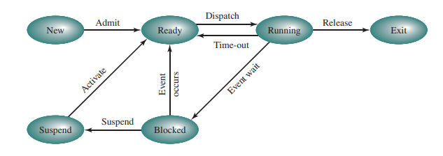

1. 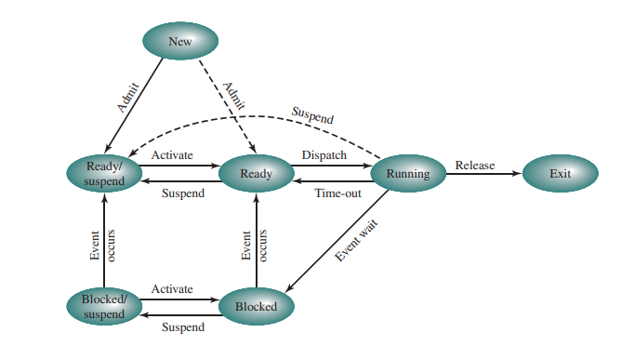Explain the process state transition diagram with two suspended states.

In a process state transition diagram with two suspended states, the additional suspended state provides more granularity in representing the various stages of process suspension. Here is an explanation of a process state transition diagram with two suspended states:

1. **Process States**:
   * **New**: The process is being created or initialized.
   * **Ready**: The process is ready to run and waiting for CPU allocation.
   * **Running**: The process is currently being executed on the CPU.
   * **Blocked**: The process is waiting for an event (e.g., I/O operation) to occur.
   * **Suspended Blocked**: The process is in a suspended state while waiting for an event to occur.
   * **Suspended Ready**: The process is in a suspended state but ready to run when resumed.
2. **State Transitions**:
   * **New to Ready**: The process transitions from the new state to the ready state when it is ready to be scheduled for execution.
   * **Ready to Running**: The process moves from the ready state to the running state when the CPU scheduler allocates the CPU to it.
   * **Running to Blocked**: If the process needs to wait for an event, it transitions from the running state to the blocked state.
   * **Blocked to Suspended Blocked**: The process can be suspended while in the blocked state, temporarily halting its execution while waiting for an event.
   * **Suspended Blocked to Ready**: When the event the process is waiting for occurs, it moves from the suspended blocked state back to the ready state.
   * **Running to Suspended Ready**: The process can be suspended while in the running state, temporarily halting its execution.
   * **Suspended Ready to Ready**: When the suspended process is ready to resume execution, it transitions back to the ready state.
3. **Illustration**:
   * The process state transition diagram with two suspended states would include arrows representing the transitions between the various states mentioned above. The addition of two suspended states allows for a more detailed representation of process suspension scenarios, such as processes waiting for events or voluntarily suspending their execution.
4. **Importance**:
   * Having two suspended states in the process state transition diagram provides a clearer depiction of the different stages of process suspension and resumption. It enables the operating system to manage processes more effectively by distinguishing between processes waiting for events and those ready to run when resumed.
5. Briefly discuss the reasons for process suspension.

Process suspension refers to the temporary halting of a process's execution by the operating system. There are several reasons why a process may be suspended, and here are some common scenarios:

1. **Waiting for I/O Operations**: Processes often need to wait for input/output operations to complete, such as reading from a file or receiving data from a network. During this waiting period, the process can be suspended to free up the CPU for other tasks.
2. **Resource Unavailability**: If a process requires a resource that is currently unavailable (e.g., memory, a hardware device), it may be suspended until the resource becomes accessible. This helps prevent the process from consuming CPU time unnecessarily.
3. **Priority Adjustment**: In a multitasking environment, the operating system may suspend lower-priority processes to give higher-priority processes more CPU time. This dynamic adjustment of process priorities helps optimize system performance.
4. **User Interaction**: Processes may be suspended when they require user input or interaction. For example, a process running a graphical user interface application may be suspended while waiting for user actions.
5. **Preemption**: Processes can be pre-empted by the operating system to allow higher-priority processes to run. When a process is preempted, it is temporarily suspended to give way to the higher-priority task.
6. **Debugging and Tracing**: During debugging or tracing activities, processes may be suspended to inspect their state, variables, or execution flow. This allows developers to analyse and troubleshoot issues in the code.
7. **Memory Management**: In systems with virtual memory, processes may be suspended to facilitate memory management operations such as swapping pages between main memory and disk. This helps optimize memory usage and system performance.
8. **Security and Isolation**: Processes can be suspended as part of security measures to isolate potentially malicious or unauthorized activities. Suspending a process can prevent it from causing harm to the system or accessing sensitive data.
9. **Synchronization**: In concurrent programming, processes may be suspended to ensure proper synchronization and coordination between multiple processes or threads. Suspending a process at specific points can help avoid race conditions and ensure data consistency.
10. Discuss the general structure of operating system control tables.

Operating system control tables are data structures used by the operating system to manage various system resources, processes, and configurations. These tables play a crucial role in organizing and tracking information related to system components. Here is a discussion on the general structure of operating system control tables:

1. **Purpose**:
   * Control tables are used to store and manage essential information about system resources, processes, devices, and other system components.
   * They provide a centralized and structured way for the operating system to access and manipulate data related to different aspects of system operation.
2. **Key Components**:
   * **Entry**: Each control table typically consists of multiple entries, with each entry representing a specific resource, process, or configuration parameter.
   * **Fields**: Entries in control tables contain fields that store relevant information about the associated resource. These fields can include identifiers, status flags, pointers to data structures, and other attributes.
   * **Pointers**: Control tables often use pointers to link related entries or data structures, enabling efficient navigation and retrieval of information.
3. **Types of Control Tables**:
   * **Process Control Block (PCB)**: A control table that stores information about processes, including process state, program counter, CPU registers, and scheduling information.
   * **File Control Block (FCB)**: Used to manage files and file-related operations, storing details such as file attributes, location on disk, and access permissions.
   * **Device Control Block (DCB)**: Contains information about devices connected to the system, including device status, configuration parameters, and I/O operation details.
   * **Memory Management Control Tables**: Used to track memory allocation, deallocation, and mapping information, ensuring efficient memory utilization.
4. **Attributes**:
   * **Identifier**: Each entry in a control table is typically assigned a unique identifier to distinguish it from other entries.
   * **Status Flags**: Flags are used to indicate the current state or condition of the resource or process associated with the entry.
   * **Pointers to Data Structures**: Control tables often include pointers to additional data structures that provide detailed information or facilitate resource management.
5. **Access and Manipulation**:
   * Operating system functions and modules access control tables to retrieve information, update status, and perform operations on system resources.
   * Control tables are typically maintained and managed by the operating system kernel to ensure data integrity and consistency.
6. **Dynamic Nature**:
   * Control tables can be dynamic in nature, with entries being created, modified, or removed based on system activities and resource allocation requirements.
   * The structure and content of control tables may evolve as the system executes different processes and interacts with external devices.
7. Briefly discuss process control structure.

The Process Control Block (PCB) is a crucial data structure used by operating systems to manage and control processes. Here is a brief discussion on the Process Control Structure:

1. **Purpose**:
   * The Process Control Block (PCB) is a data structure that contains essential information about a process in the operating system.
   * It serves as the central repository of process-related information and is used by the operating system to manage and control processes effectively.
2. **Key Components**:
   * **Process ID**: A unique identifier assigned to each process to distinguish it from others in the system.
   * **Process State**: Indicates the current state of the process (e.g., running, ready, blocked).
   * **Program Counter**: Stores the address of the next instruction to be executed by the process.
   * **CPU Registers**: Contains the values of CPU registers associated with the process.
   * **Memory Management Information**: Includes details about the process's memory allocation, such as base and limit registers.
   * **Scheduling Information**: Contains data related to process priority, scheduling queue pointers, and other scheduling parameters.
   * **I/O Status Information**: Tracks the status of I/O operations initiated by the process.
   * **Accounting Information**: Records statistics like CPU usage, execution time, and other performance metrics.
   * **Pointer to Parent Process**: Points to the parent process of the current process, useful for process hierarchy management.
3. **Dynamic Nature**:
   * The PCB is dynamically updated as the process progresses through different states and interacts with system resources.
   * When a process is created, the operating system allocates memory for its PCB, and as the process executes, the PCB is modified to reflect changes in the process state and attributes.

**Chapter-7**

1. Explain the requirements of memory management in detail.

Memory management in operating systems involves various requirements to ensure efficient utilization of memory resources. Let's discuss each of the specified points in detail:

1. **Relocation**:
   * **Requirement**: The relocation requirement in memory management involves the ability to load programs into any available area of memory. This is essential to accommodate programs of varying sizes and prevent conflicts between programs.
   * **Implementation**: Operating systems use techniques like base and limit registers or dynamic loading to relocate programs in memory. Base and limit registers define the base address and size of the memory segment allocated to a program, allowing it to be loaded at any location in memory.
2. **Sharing**:
   * **Requirement**: Sharing memory segments among multiple processes is crucial for optimizing memory usage and facilitating inter-process communication.
   * **Implementation**: Operating systems implement shared memory mechanisms that allow multiple processes to access and modify the same memory segment. This enables efficient data sharing and communication between processes.
3. **Protection**:
   * **Requirement**: Memory protection is necessary to prevent unauthorized access or modification of memory regions by processes. It ensures data integrity and security.
   * **Implementation**: Operating systems use hardware mechanisms like memory protection units (MPUs) and software-based access control to enforce memory protection policies. MPUs restrict memory access based on permissions assigned to memory segments.
4. **Logical Organization**:
   * **Requirement**: Memory should be logically organized to provide a uniform view to processes running on the system. This includes dividing memory into segments or pages for efficient allocation and management.
   * **Implementation**: Operating systems organize memory into logical units such as segments or pages. Segmentation and paging are common techniques used for logical organization, allowing processes to access memory in a structured manner.
5. **Physical Organization**:
   * **Requirement**: Physical organization in memory management involves how the actual memory hardware is structured and managed by the operating system.
   * **Implementation**: This includes addressing memory cells, memory mapping, memory banks, memory interfacing, cache memory, and memory modules. The physical organization ensures efficient data storage, retrieval, and access within the memory subsystem.
6. Briefly discuss fixed partitioning and dynamic partitioning approaches in memory management.

**Fixed Partitioning**:

* **Description**: In fixed partitioning, the physical memory is divided into fixed-size partitions at system boot time. Each partition can accommodate one process, and the size of the partition remains constant throughout the system's operation.
* **Allocation**: When a process is loaded into memory, it is placed in a partition that is large enough to accommodate it. If a process is smaller than the partition size, the remaining space in the partition is wasted (internal fragmentation).
* **Advantages**:
  + Simple and easy to implement.
  + No need for dynamic memory management algorithms.
* **Disadvantages**:
  + Internal fragmentation can lead to inefficient memory usage.
  + Limited flexibility in accommodating processes of varying sizes.

**Dynamic Partitioning**:

* **Description**: In dynamic partitioning, memory is divided into variable-sized partitions based on the size of the processes being loaded. When a process is loaded, it is allocated memory based on its size, and the unused memory is returned to the pool of available memory.
* **Allocation**: Dynamic partitioning requires memory allocation and deallocation algorithms to manage the varying sizes of processes. Common allocation algorithms include first fit, best fit, and worst fit.
* **Advantages**:
  + Efficient memory utilization as partitions are tailored to process sizes.
  + Flexibility in accommodating processes of different sizes.
* **Disadvantages**:
  + Fragmentation can occur, leading to inefficient memory usage (external fragmentation).
  + Overhead associated with managing variable-sized partitions.

1. Briefly explain the two characteristics of paging and segmentation as a breakthrough in memory Management.

**Paging**:

1. **Characteristics**:
   * **Equal-sized Pages**: Paging divides both physical and logical memory into fixed-size pages. This uniform page size simplifies memory management by eliminating the need to allocate contiguous memory blocks for processes.
   * **Address Translation**: Paging uses a page table to map logical addresses generated by the CPU to physical addresses in memory. This translation allows processes to access non-contiguous physical memory locations, enhancing memory utilization.

**Breakthrough in Memory Management**:

* **Efficient Memory Allocation**: Paging revolutionized memory management by enabling efficient allocation of memory to processes. The use of fixed-size pages eliminates external fragmentation and allows for better memory utilization.
* **Simplified Address Translation**: The page table mechanism simplifies address translation, making it easier to manage memory mappings between logical and physical addresses. This simplification enhances system performance and facilitates memory protection.

**Segmentation**: 2. **Characteristics**:

* **Variable-sized Segments**: Segmentation divides logical memory into variable-sized segments based on the program's structure (e.g., code, data, stack). Each segment represents a logical unit of the program.
* **Logical Address Space**: Segmentation provides a logical view of memory that matches the program's structure, making it easier to manage and organize program data.

**Breakthrough in Memory Management**:

* **Program Structure Representation**: Segmentation introduced a breakthrough by aligning memory management with the logical structure of programs. This representation simplifies memory organization and enhances program readability and maintenance.
* **Enhanced Memory Protection**: Segmentation allows for finer-grained memory protection by assigning different access permissions to each segment. This feature enhances system security and prevents unauthorized access to memory regions.

**Chapter-8**

1. Briefly explain the characteristics of paging and segmentation without virtual memory.

Paging and segmentation are memory management techniques used in operating systems. Here are the characteristics of paging and segmentation without virtual memory:

1. **Paging**:
   * In paging, the physical memory is divided into fixed-size blocks called frames, and the logical memory is divided into fixed-size blocks called pages.
   * Each process's address space is divided into pages of the same size, and the pages are mapped to frames in physical memory.
   * Paging allows for efficient memory allocation and management but may lead to internal fragmentation due to the fixed-size allocation units.
   * Without virtual memory, paging directly maps logical addresses to physical addresses, and the entire process must be loaded into memory for execution.
2. **Segmentation**:
   * Segmentation divides the logical memory into variable-sized segments based on the program's structure (e.g., code segment, data segment).
   * Each segment represents a logical unit of the program and is mapped to a physical memory location.
   * Segmentation provides a more flexible memory allocation scheme compared to paging but can lead to external fragmentation.
   * Without virtual memory, segmentation simplifies memory management by allowing different parts of a program to be stored in separate segments.
3. What do you understand by the term virtual memory? Briefly explain the characteristics of paging and segmentation with virtual memory

**Virtual Memory**: Virtual memory is a memory management technique that provides an illusion to the user that they have a large, contiguous, and private address space for their programs, even though physical memory may be limited. It allows programs to execute as if they have access to more memory than is physically available by using disk storage as an extension of RAM. Virtual memory enables efficient and flexible memory allocation, protection, and sharing among processes.

**Characteristics of Paging and Segmentation with Virtual Memory**:

1. **Paging with Virtual Memory**:
   * In virtual memory systems using paging, the logical address space of a process is divided into fixed-size pages.
   * Pages are mapped to frames in physical memory or to disk storage when not in RAM.
   * Paging allows for non-contiguous allocation of memory, enabling efficient use of physical memory and reducing internal fragmentation.
   * When a page is accessed but not in physical memory, a page fault occurs, triggering the operating system to bring the required page into memory from disk.
2. **Segmentation with Virtual Memory**:
   * Segmentation in virtual memory systems divides the logical address space of a process into variable-sized segments based on the program's structure.
   * Each segment is mapped to a segment in physical memory or disk storage, allowing for flexible memory allocation.
   * Segmentation helps in organizing memory based on the program's logical structure, such as code, data, and stack segments.
   * Virtual memory systems using segmentation provide protection and isolation between segments, enhancing security and stability.
3. 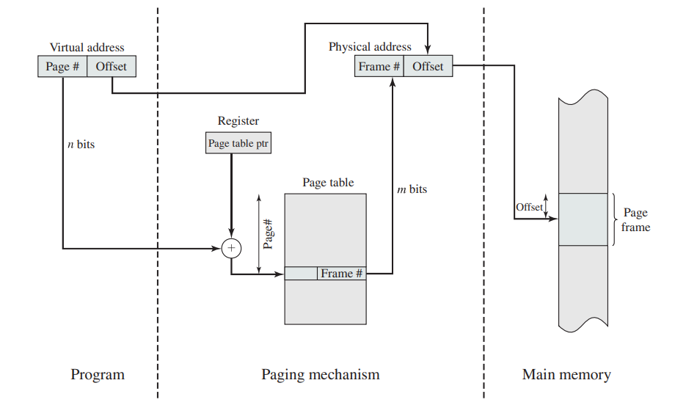Explain the mechanism of translating virtual addresses into physical addresses using paging paging-only mechanism. Draw the necessary diagram.

In a paging-only mechanism for translating virtual addresses into physical addresses, the virtual address space of a process is divided into fixed-size blocks called pages, and the physical memory is divided into fixed-size blocks called frames. The translation process involves mapping virtual pages to physical frames.

Here is the mechanism of translating virtual addresses into physical addresses using paging-only:

1. **Virtual Address Format**:
   * A virtual address consists of two parts: a page number (p) and an offset within the page (d).
   * The page number is used to index into a page table to find the corresponding frame number in physical memory.
   * The offset specifies the location within the frame where the data is stored.
2. **Page Table**:
   * Each process has its own page table that maps virtual pages to physical frames.
   * The page table is typically stored in physical memory and is indexed by the page number from the virtual address.
3. **Translation Process**:
   * When a process generates a virtual address, the operating system extracts the page number (p) and offset (d).
   * The page number is used as an index into the page table to retrieve the corresponding frame number (f).
   * The frame number is combined with the offset to form the physical address.

In the diagram:

* The virtual address (p, d) is split into the page number (p) and offset (d).
* The page number (p) is used to index into the page table to retrieve the frame number (f).
* The physical address is formed by combining the frame number (f) with the offset (d) to access the actual data in physical memory.

This paging-only mechanism simplifies memory management by allowing for non-contiguous allocation of memory and efficient translation of virtual addresses to physical addresses.

1. Explain the mechanism of translating virtual addresses into physical addresses using a segmentation-only mechanism. Draw the necessary diagram.

In a segmentation-only mechanism for translating virtual addresses into physical addresses, the virtual address space of a process is divided into variable-sized segments based on the program's logical structure. Each segment is mapped to a segment in physical memory. The translation process involves mapping virtual segments to physical segments.

Here is the mechanism of translating virtual addresses into physical addresses using a segmentation-only approach:

1. **Virtual Address Format**:
   * A virtual address in a segmentation-only system consists of two parts: a segment number (s) and an offset within the segment (d).
   * The segment number is used to index into a segment table to find the corresponding physical segment base address.
   * The offset specifies the location within the segment where the data is stored.
2. **Segment Table**:
   * Each process has its own segment table that maps virtual segments to physical segments.
   * The segment table is typically stored in physical memory and is indexed by the segment number from the virtual address.
3. **Translation Process**:
   * When a process generates a virtual address, the operating system extracts the segment number (s) and offset (d).
   * The segment number is used as an index into the segment table to retrieve the base address of the corresponding physical segment.
   * The physical address is formed by adding the offset to the base address of the physical segment.
4. **Diagram**:
   * Below is a simple diagram illustrating the translation process using a segmentation-only mechanism:

In the diagram:

* The virtual address (s, d) is split into the segment number (s) and offset (d).
* The segment number (s) is used to index into the segment table to retrieve the base address of the corresponding physical segment.
* The physical address is formed by adding the offset (d) to the base address of the physical segment to access the actual data in physical memory.

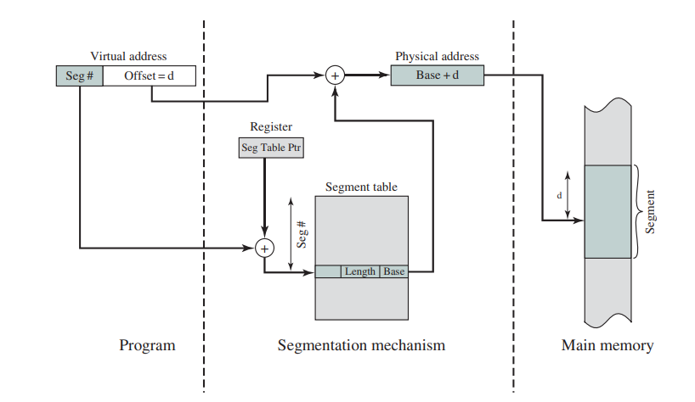This segmentation-only mechanism simplifies memory management by organizing memory based on the program's logical structure and providing protection and isolation between segments.

1. Explain the mechanism of translating virtual addresses into physical addresses using combined paging and segmentation mechanisms.

In systems that use a combined paging and segmentation mechanism for translating virtual addresses into physical addresses, the benefits of both paging and segmentation are leveraged to manage memory efficiently. This approach combines the advantages of paging, such as efficient memory allocation and management, with the benefits of segmentation, such as logical organization of memory based on program structure.

Here is an overview of the mechanism of translating virtual addresses into physical addresses using combined paging and segmentation:

1. **Virtual Address Format**:
   * A virtual address in a combined paging and segmentation system typically consists of three parts: a segment number (s), a page number (p), and an offset within the page (d).
   * The segment number (s) is used to index into a segment table to find the corresponding segment descriptor.
   * The segment descriptor contains information about the segment, including the base address of the segment and the page table pointer.
   * The page number (p) is used to index into the page table pointed to by the segment descriptor to find the frame number in physical memory.
   * The offset (d) specifies the location within the frame where the data is stored.
2. **Translation Process**:
   * When a process generates a virtual address, the operating system extracts the segment number (s), page number (p), and offset (d).
   * The segment number (s) is used to index into the segment table to retrieve the segment descriptor.
   * The segment descriptor provides the base address of the segment and the pointer to the page table.
   * The page number (p) is used to index into the page table to find the frame number in physical memory.
   * The physical address is formed by combining the frame number with the offset to access the actual data in physical memory.
3. **Advantages**:
   * The combined mechanism allows for a hierarchical organization of memory, where segments are divided into pages for efficient memory management.
   * It provides flexibility in memory allocation and protection by using segmentation and efficient mapping of virtual pages to physical frames through paging.
   * The system benefits from the logical structure of segmentation and the efficient memory utilization of paging.

By combining paging and segmentation mechanisms, the system can effectively manage memory, provide protection and isolation between segments, and optimize memory usage for processes. This approach offers a balance between the benefits of both paging and segmentation in translating virtual addresses into physical addresses.

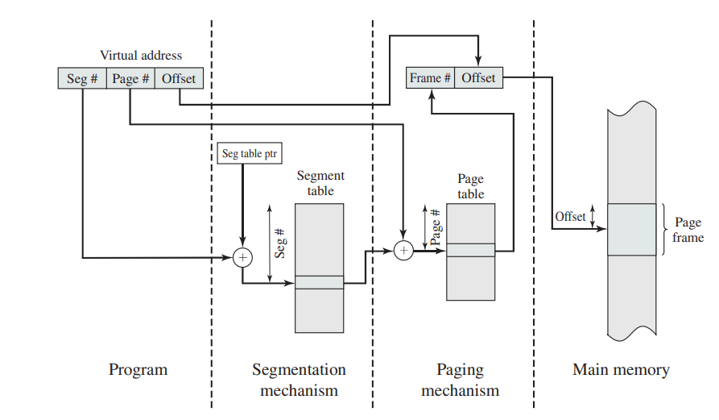

1. Briefly discuss operating system policies for virtual memory.

Operating systems implement various policies for managing virtual memory efficiently. These policies help in optimizing memory usage, improving performance, and providing a seamless experience to users. Here are some key operating system policies for virtual memory:

1. **Page Replacement Policy**:
   * When a page fault occurs and a page needs to be brought into memory, the operating system must decide which page to replace if there are no free frames available.
   * Popular page replacement algorithms include Least Recently Used (LRU), First-In-First-Out (FIFO), Clock (Second-Chance), and Optimal.
   * The choice of page replacement policy impacts system performance, as different algorithms have varying overheads and efficiency in different scenarios.
2. **Page Size**:
   * The operating system determines the size of pages used in the virtual memory system.
   * Larger page sizes can reduce the overhead of managing page tables but may lead to more internal fragmentation.
   * Smaller page sizes can reduce internal fragmentation but may increase the overhead of managing a larger number of pages.
3. **Address Translation Mechanism**:
   * The operating system decides how virtual addresses are translated into physical addresses.
   * This can involve using segmentation, paging, or a combination of both mechanisms.
   * The choice of address translation mechanism affects memory management efficiency, protection, and isolation between processes.
4. **Memory Allocation Policy**:
   * Operating systems implement memory allocation policies to manage the allocation and deallocation of memory for processes.
   * Policies like first fit, best fit, worst fit, and buddy system are used to allocate memory blocks to processes.
   * Efficient memory allocation policies help in reducing fragmentation and improving memory utilization.
5. **Swapping Policy**:
   * Swapping involves moving entire processes or parts of processes between main memory and secondary storage.
   * The operating system decides when and which processes to swap out to optimize memory usage.
   * Swapping policies aim to minimize the impact on system performance while ensuring efficient use of memory resources.
6. **Memory Protection**:
   * Operating systems enforce memory protection policies to prevent processes from accessing memory locations outside their allocated address space.
   * Memory protection mechanisms help in ensuring the security and stability of the system by isolating processes and preventing unauthorized access to memory.